**Model deployment**

**Task1: saving trained model as .pkl**

* **Install joblib that helps to import and save the model as .pkl**

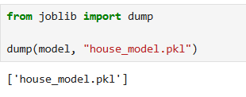

**Task 2: using Gradio library to provide a GUI for House price prediction**

**Step 1: install gradio library**

* **Pip install gradio**

**The interface is created like this**

Then the interface is look like this Insert Values to be predicted

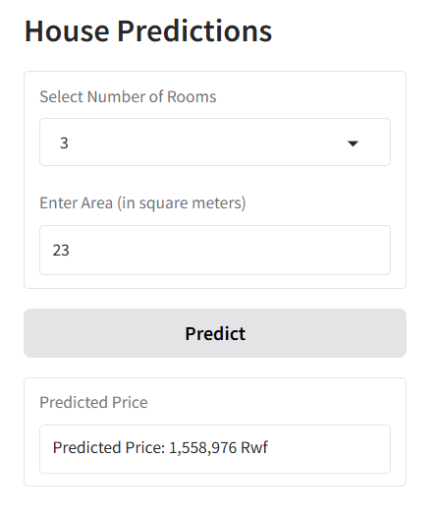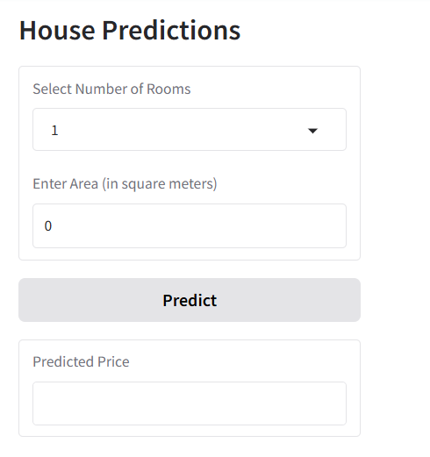

**Task 3:** Using APIs on Html

* We create two folders one named **API** and Other Named **Front_End** the API folder contain python file and model that will be used

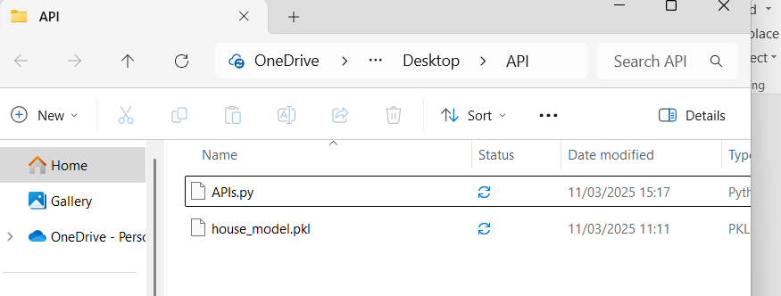

* We create one html file that will use API to use mode , that file contain Java Script that will help us to run API this file is look like this

